CORRELATION AND OUTLIERS
POSTIVE CORRELATION
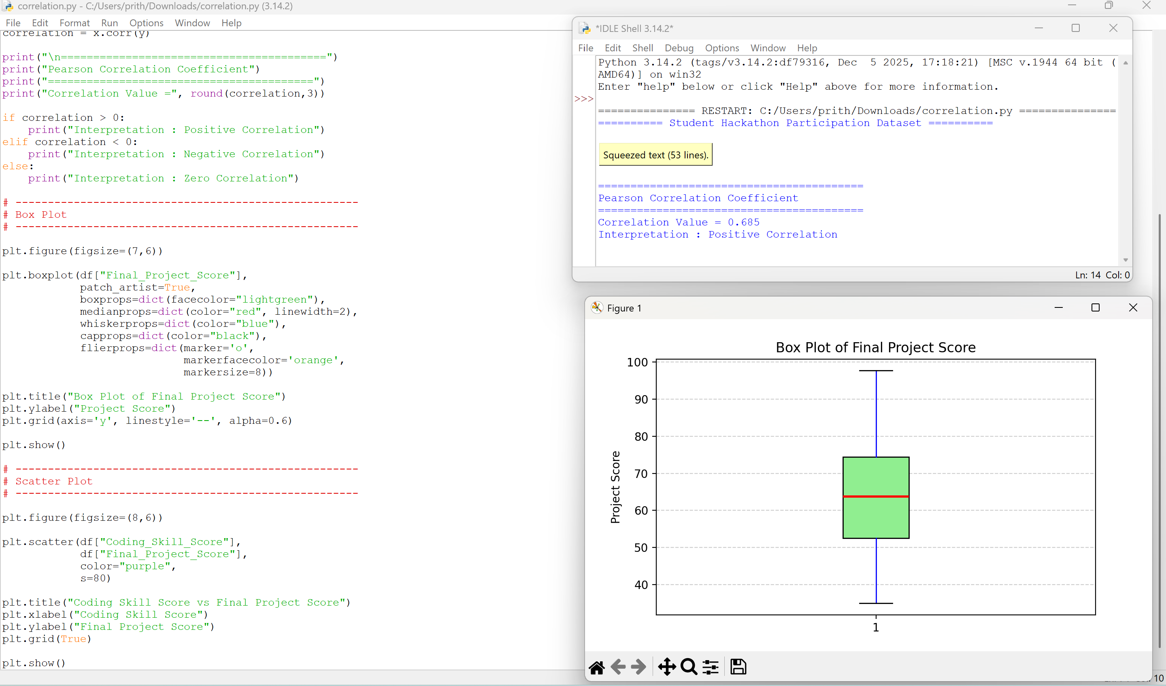
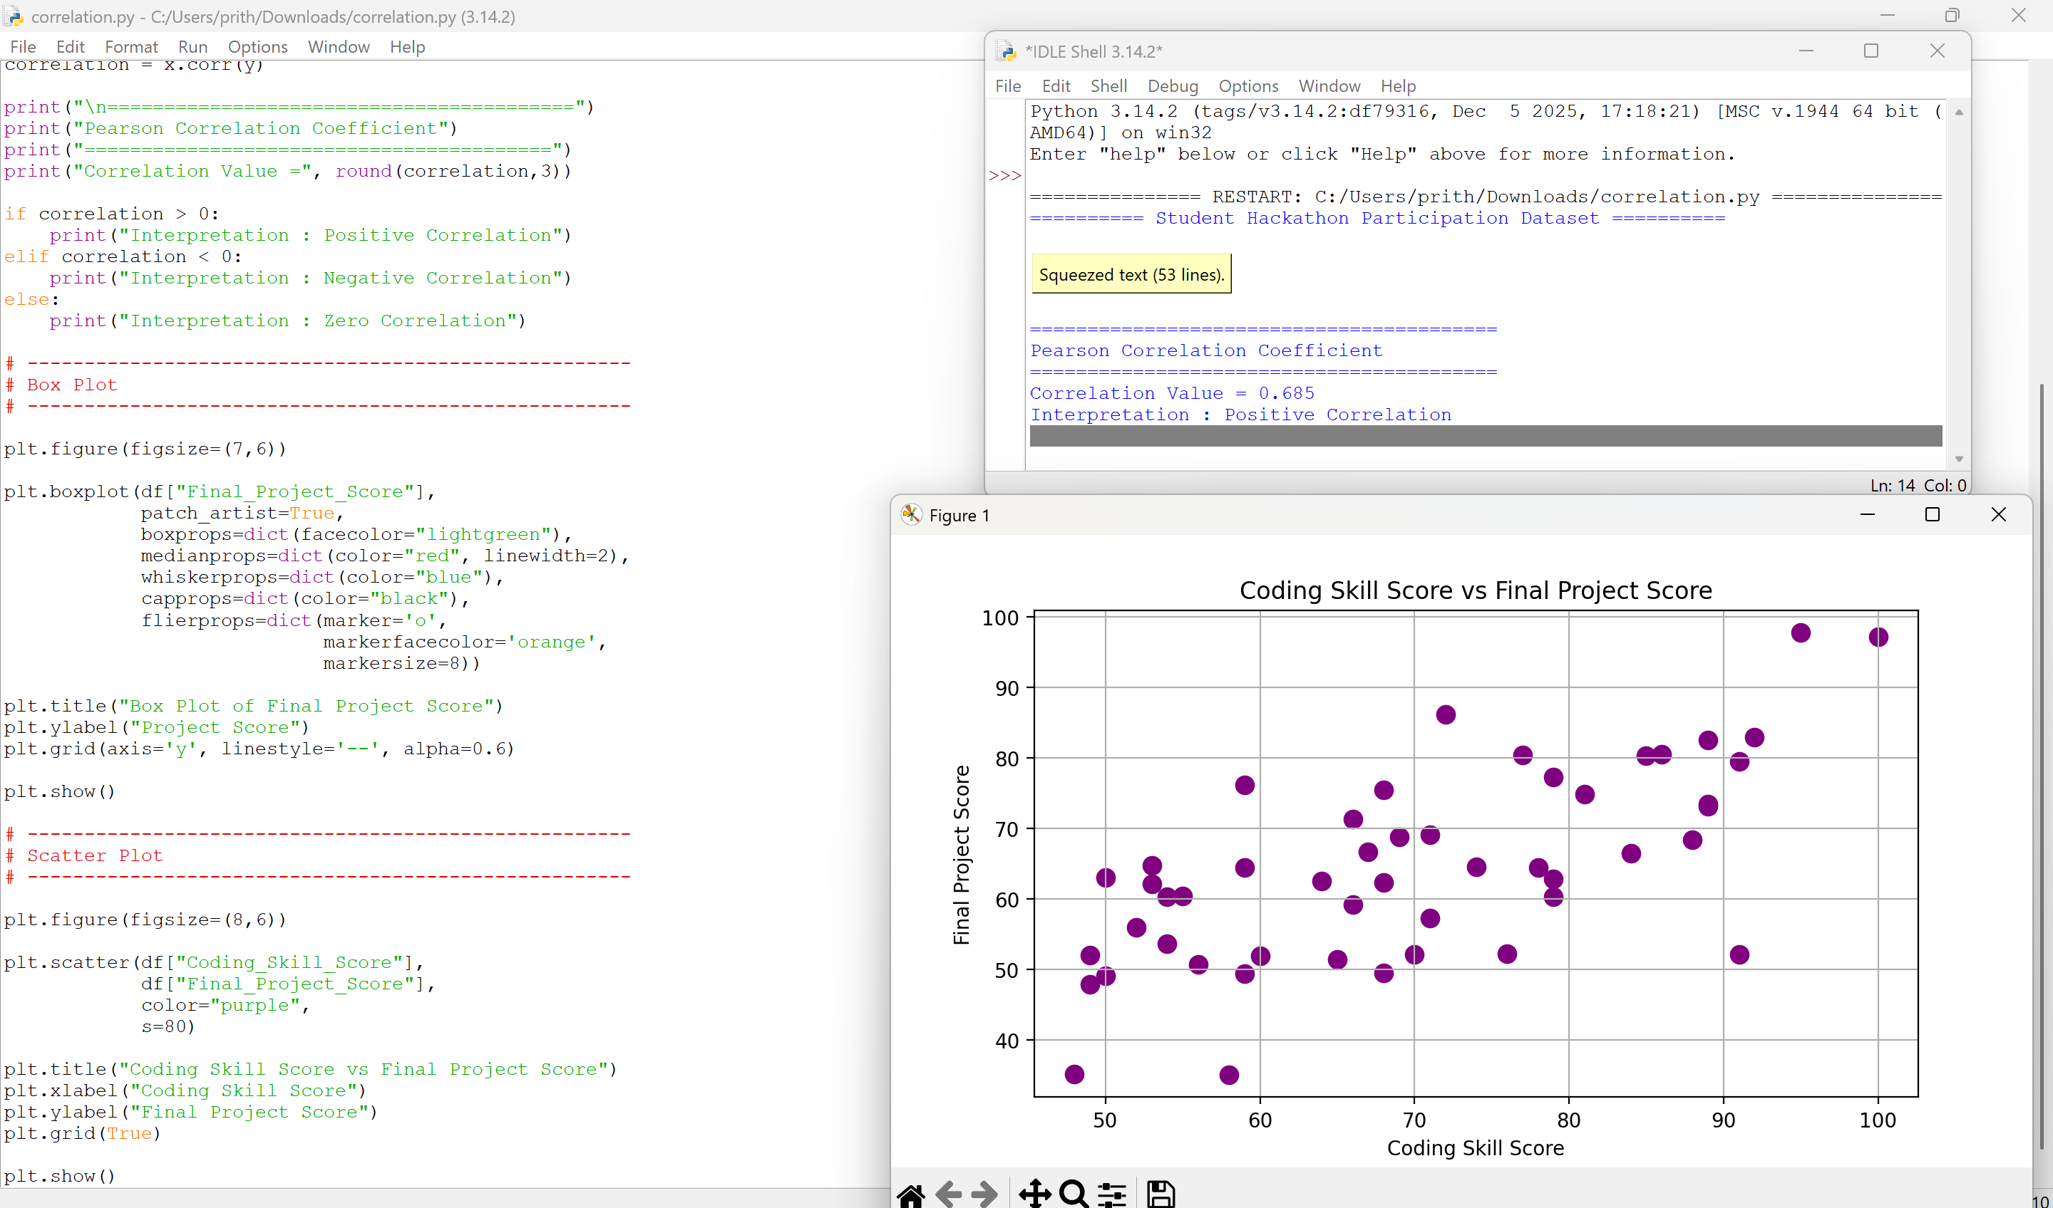
Explanation
- As the Coding Skill Score increases, the Final Project Score also increases.
- The points move from the bottom-left toward the top-right.
- This upward trend indicates a positive correlation.

Example:
- Coding Skill = 50 → Project Score = 55
- Coding Skill = 90 → Project Score = 92
Interpretation:
Students with higher coding skills tend to achieve higher project scores.
NEGATIVE CORRELATION
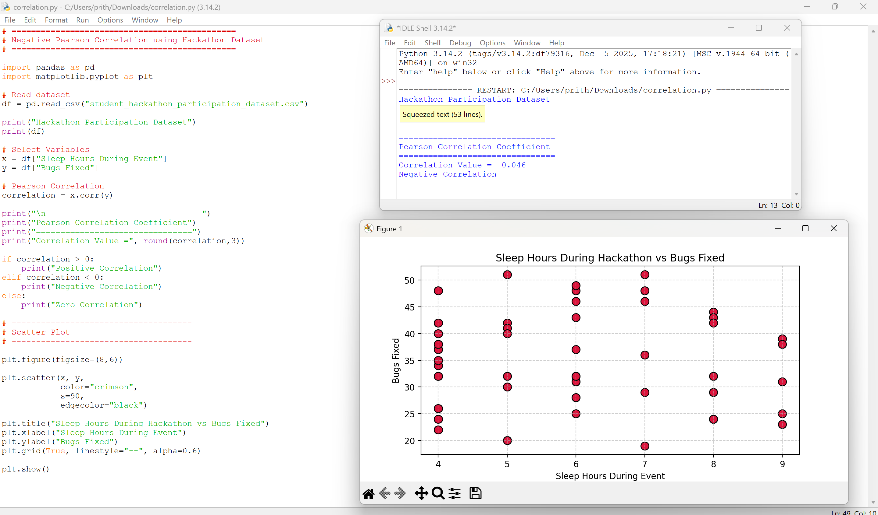
HACKATHON DATASET
Student_ID | Coding_Skill_Score | Hackathons_Attended | Teamwork_Score | Sleep_Hours_During_Event | Bugs_Fixed | Final_Project_Score
HACK001 | 65 | 2 | 75 | 9 | 31 | 51.4
HACK002 | 79 | 1 | 73 | 8 | 24 | 62.8
HACK003 | 58 | 0 | 55 | 7 | 46 | 35
HACK004 | 50 | 8 | 77 | 4 | 40 | 63
HACK005 | 85 | 10 | 87 | 4 | 32 | 80.3
HACK006 | 59 | 0 | 85 | 5 | 42 | 49.4
HACK007 | 79 | 1 | 86 | 6 | 28 | 60.3
HACK008 | 81 | 10 | 62 | 6 | 25 | 74.8
HACK009 | 49 | 9 | 53 | 8 | 44 | 52
HACK010 | 79 | 6 | 99 | 6 | 37 | 77.3
HACK011 | 74 | 5 | 69 | 5 | 30 | 64.5
HACK012 | 60 | 1 | 86 | 6 | 48 | 51.9
HACK013 | 66 | 11 | 78 | 6 | 31 | 71.3
HACK014 | 71 | 2 | 98 | 6 | 31 | 69.1
HACK015 | 71 | 0 | 92 | 4 | 37 | 57.3
HACK016 | 67 | 9 | 81 | 8 | 43 | 66.6
HACK017 | 50 | 4 | 80 | 9 | 39 | 49.1
HACK018 | 89 | 4 | 91 | 8 | 32 | 73.4
HACK019 | 69 | 10 | 72 | 4 | 42 | 68.8
HACK020 | 84 | 1 | 81 | 4 | 26 | 66.4
HACK021 | 53 | 11 | 65 | 7 | 48 | 64.7
HACK022 | 76 | 1 | 60 | 7 | 36 | 52.2
HACK023 | 53 | 6 | 85 | 6 | 49 | 62.1
HACK024 | 88 | 6 | 64 | 5 | 20 | 68.4
HACK025 | 59 | 10 | 64 | 4 | 48 | 64.4
HACK026 | 56 | 4 | 68 | 4 | 38 | 50.7
HACK027 | 68 | 9 | 86 | 6 | 32 | 75.4
HACK028 | 77 | 9 | 91 | 9 | 25 | 80.4
HACK029 | 100 | 12 | 93 | 8 | 24 | 97.1
HACK030 | 70 | 1 | 80 | 9 | 39 | 52.1
HACK031 | 49 | 3 | 78 | 5 | 41 | 47.9
HACK032 | 48 | 1 | 50 | 8 | 42 | 35.1
HACK033 | 68 | 9 | 51 | 4 | 34 | 62.3
HACK034 | 54 | 10 | 66 | 6 | 46 | 60.3
HACK035 | 52 | 7 | 79 | 7 | 51 | 55.9
HACK036 | 54 | 1 | 97 | 6 | 43 | 53.6
HACK037 | 89 | 2 | 83 | 4 | 24 | 73.1
HACK038 | 78 | 5 | 59 | 9 | 23 | 64.4
HACK039 | 64 | 10 | 55 | 9 | 38 | 62.5
HACK040 | 55 | 5 | 99 | 5 | 51 | 60.4
HACK041 | 59 | 9 | 100 | 5 | 40 | 76.1
HACK042 | 92 | 12 | 64 | 5 | 32 | 82.9
HACK043 | 91 | 0 | 51 | 6 | 32 | 52.1
HACK044 | 89 | 9 | 72 | 7 | 29 | 82.5
HACK045 | 68 | 1 | 64 | 4 | 35 | 49.5
HACK046 | 66 | 3 | 80 | 8 | 29 | 59.2
HACK047 | 86 | 5 | 91 | 4 | 22 | 80.5
HACK048 | 95 | 11 | 98 | 5 | 30 | 97.7
HACK049 | 72 | 12 | 90 | 6 | 28 | 86.1
HACK050 | 91 | 6 | 79 | 7 | 19 | 79.5

OUTLIERS
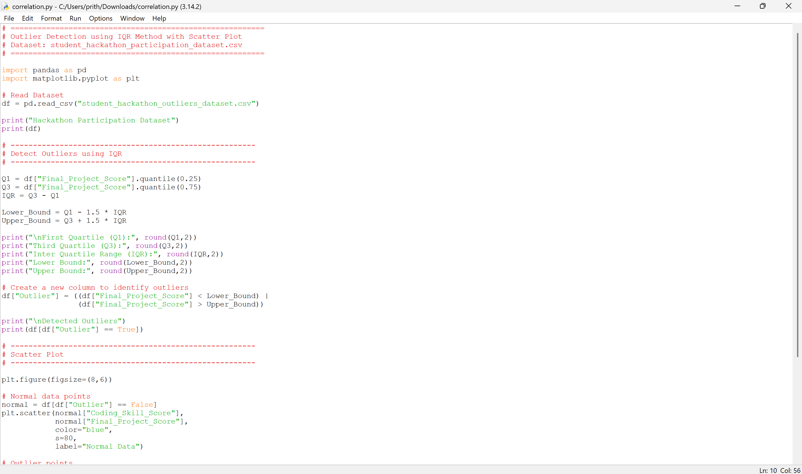
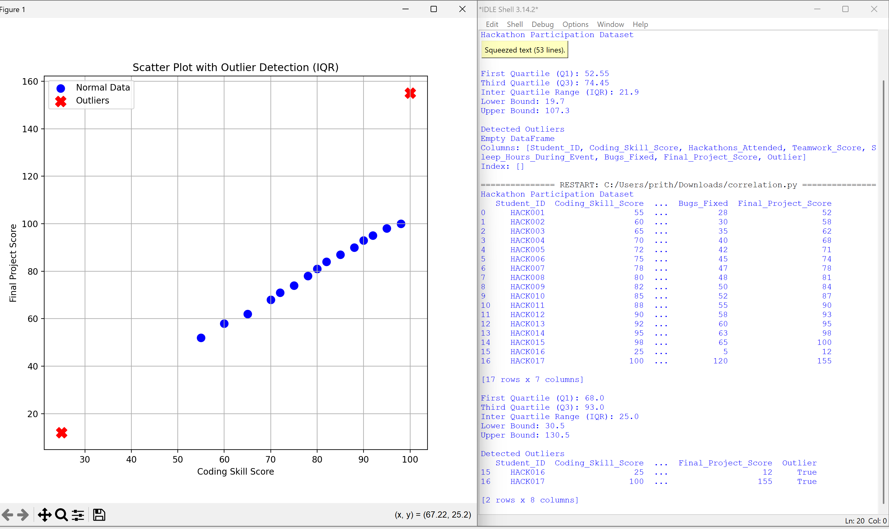
1. Normal Data Points (Blue Circles)
- Most students are clustered together in the middle of the graph.
- Their Coding Skill Score ranges from about 55 to 98.
- Their Final Project Score ranges from about 52 to 100.
- The points form an upward trend, showing that higher coding skills are generally associated with higher project scores.
2. Lower Outlier (HACK016)
- Located at the bottom-left of the graph.
- Coding Skill Score = 25
- Final Project Score = 12
This student is much lower than the rest of the data and lies below the lower IQR bound, so it is detected as an outlier.
3. Upper Outlier (HACK017)
- Located at the top-right of the graph.
- Coding Skill Score = 100
- Final Project Score = 155
This student has an unusually high project score that is above the upper IQR bound, so it is also detected as an outlier.
Why Are These Points Called Outliers?
The IQR method calculates:
- Q1 (First Quartile)
- Q3 (Third Quartile)
- IQR = Q3 − Q1
Then it computes:
- Lower Bound = Q1 − 1.5 × IQR
- Upper Bound = Q3 + 1.5 × IQR
Any observation that falls:
- Below the Lower Bound, or
- Above the Upper Bound
is classified as an outlier.
Interpretation
- Most students have similar coding and project scores, so they appear clustered together.
- HACK016 is unusually low and is detected as a lower outlier.
- HACK017 is unusually high and is detected as an upper outlier.
- These outliers are highlighted with red X markers, making them easy to distinguish from the normal observations.

